Events

Contents

1. Introduction 3
2. Workflow diagram to deploy the stack 3
3. Create stack for the Events 4
4. Plan the Job 7
5. Apply the Job 8
6. Verify in the Console 9
7. Destroy the stack 11

Introduction

Rules trigger actions for selected event conditions.Oracle Cloud Infrastructure Events enables to create automation based on the state changes of resources throughout the tenancy. Use Events to allow development teams to automatically respond when a resource changes its state.
Work with events by creating rules. Rules include a filter define to specify events produced by the resources in your tenancy. The filter is flexible:
- Define filters that match only certain events or all events.
- Define filters based on the way resources are tagged or the presence of specific values in attributes from the event itself.

Workflow diagram to deploy the stack

Below diagram shows how the Terraform Artifact are applied in the OCI. While creating a ORM stack, using terraform deliverables Init, Plan and Apply is the flow to provision the resource in the OCI. We can have the deliverables in any of below.

- GitLab/GitHub Repo
- Bitbucket
- Can be in folder/.zip in the local disk
- Object Storage Bucket
- Can be in compartment
- Oracle provided Template

Pre-Request
- Create a Topic before events code deployed

Create stack for the Events

Go to OCI Console Developer Services Resource Manager Stacks select the compartment Create Stack

My Configuration Folder Browse Select the “Events” folder that contains the terraform Upload

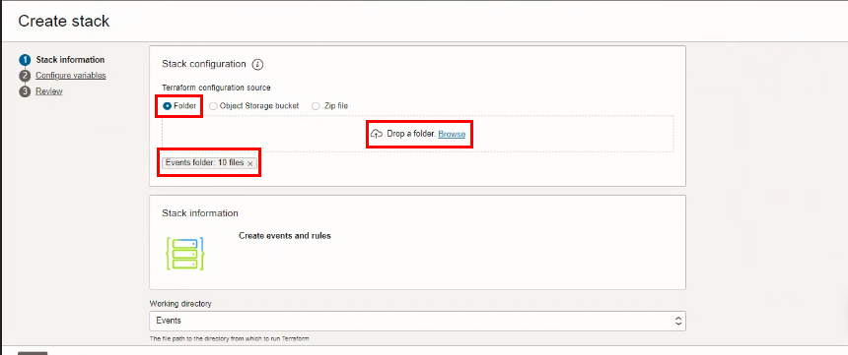

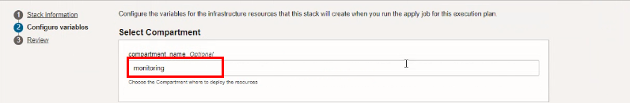

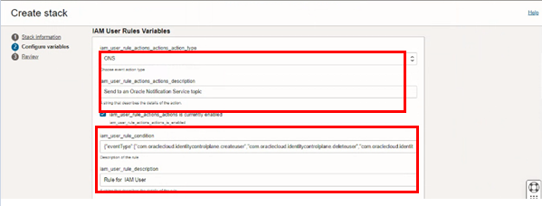

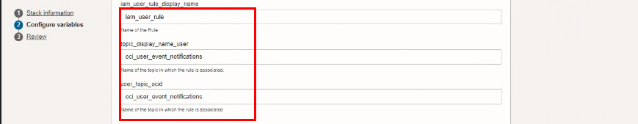
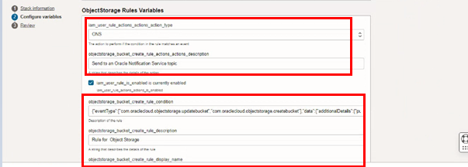

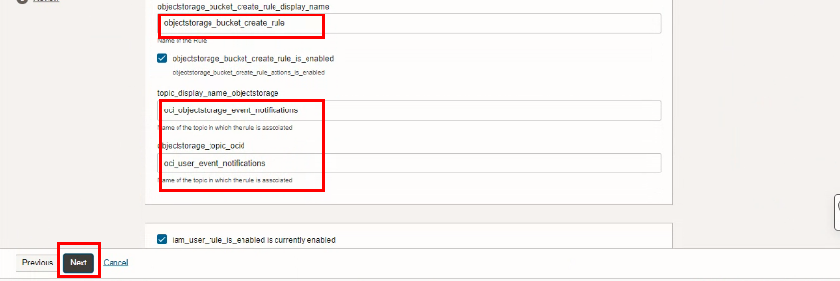

Click “NEXT”
Select the parameters as per the below screen,

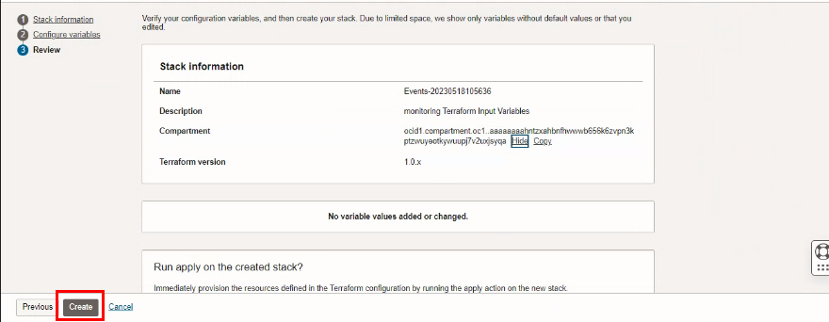
Click “NEXT” Click “CREATE”

Plan the Job
Click the “Plan”

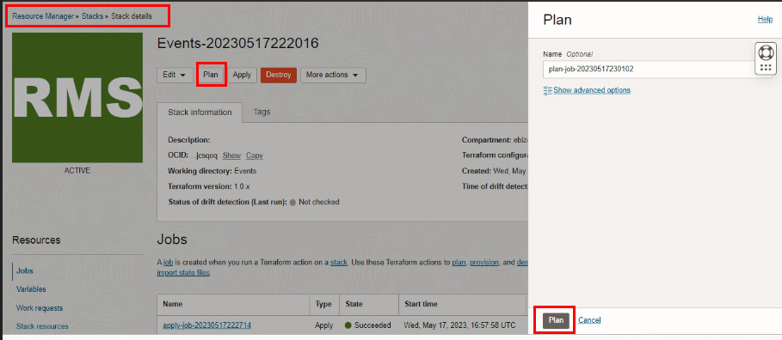

Verify the Plan is successful

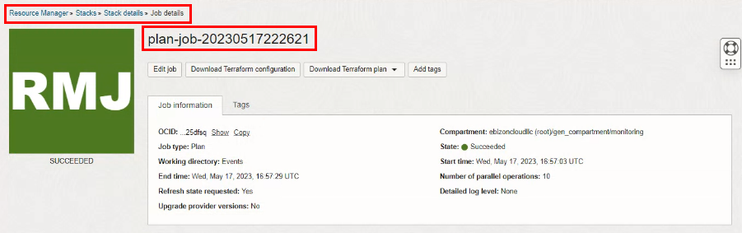

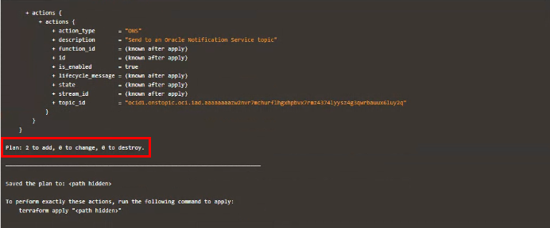

Apply the Job
Once the “plan” is success, now click “Apply”

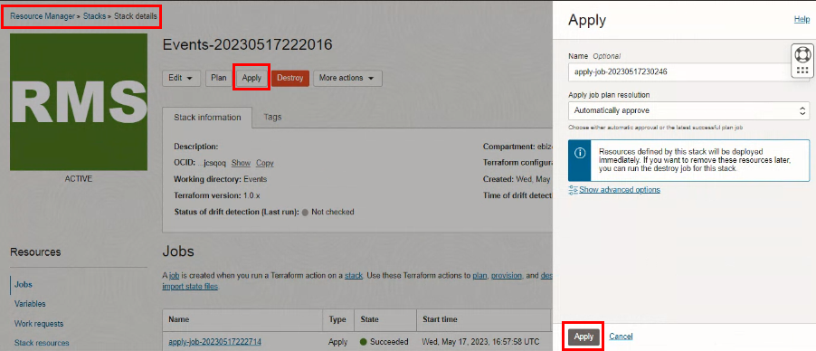

Verify the Apply is successful.
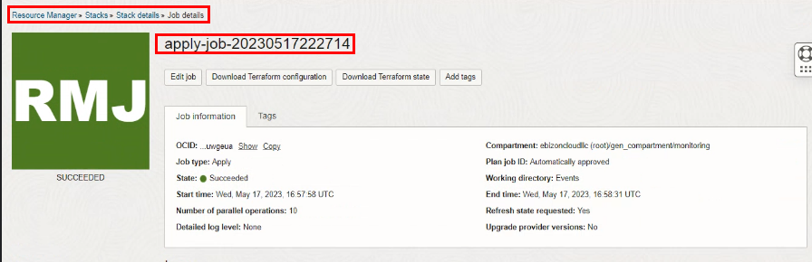

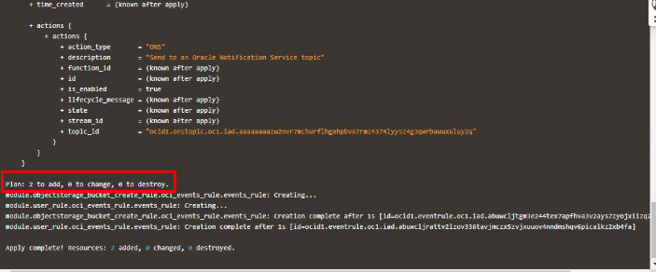

Verify in the Console
Go to OCI Console Application integration Event Services Rules objectstorage_bucket_create_rule

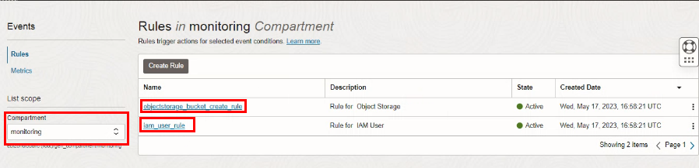

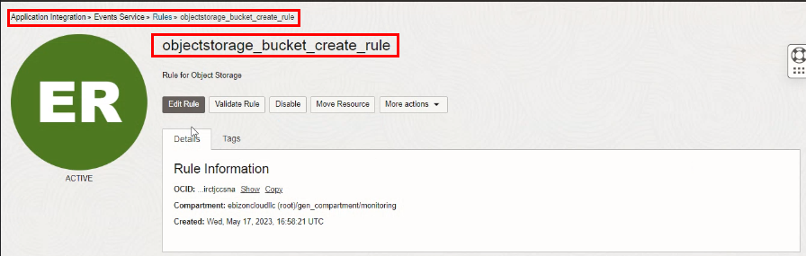

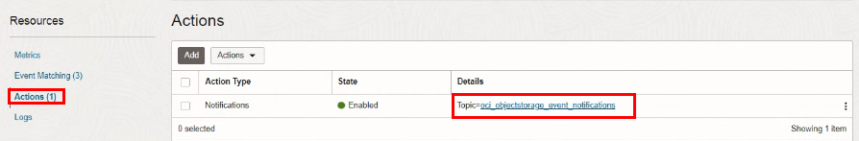

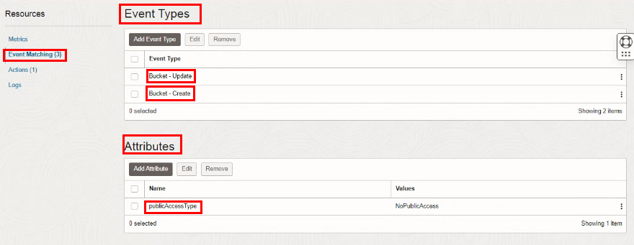

Go to OCI Console Application integration Event Services Rules iam_user_rule

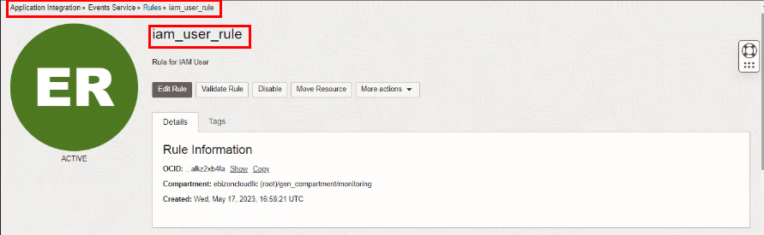

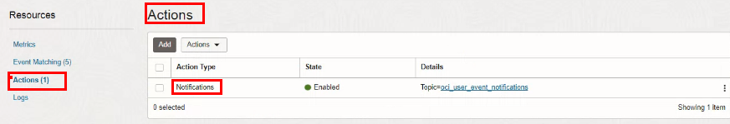

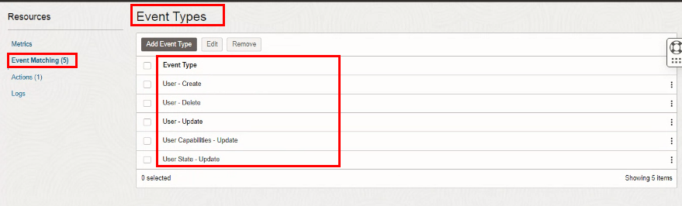

Destroy the stack
Create a destroy job in Resource Manager to release resources associated with a stack and clean up the tenancy. Once destroyed data cannot be recovered from resources.

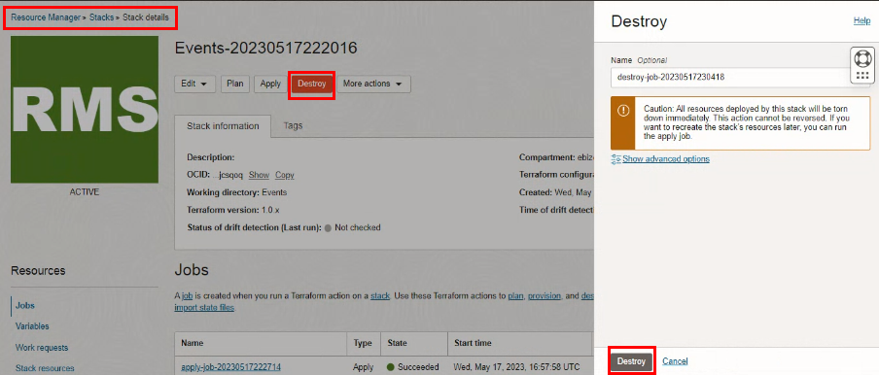

# END #

